**Course Specialist Test 1 Year 12**

Student name: ________________ Teacher name: ________________

**Task type: Response/Investigation**

**Reading time for this test : 5 mins**

**Working time allowed for this task: 40 mins**

**Number of questions: 7**

**Materials required:** No cals allowed!!

Standard items: Pens (blue/black preferred), pencils (including coloured), sharpener, correction fluid/tape, eraser, ruler, highlighters

Special items: Drawing instruments, templates, NO notes allowed!

**Marks available: 41 marks**

**Task weighting: 13%**

**Formula sheet provided: no, but formulae stated on page 2**

**Note: All part questions worth more than 2 marks require working to obtain full marks.**

**Useful formulae**

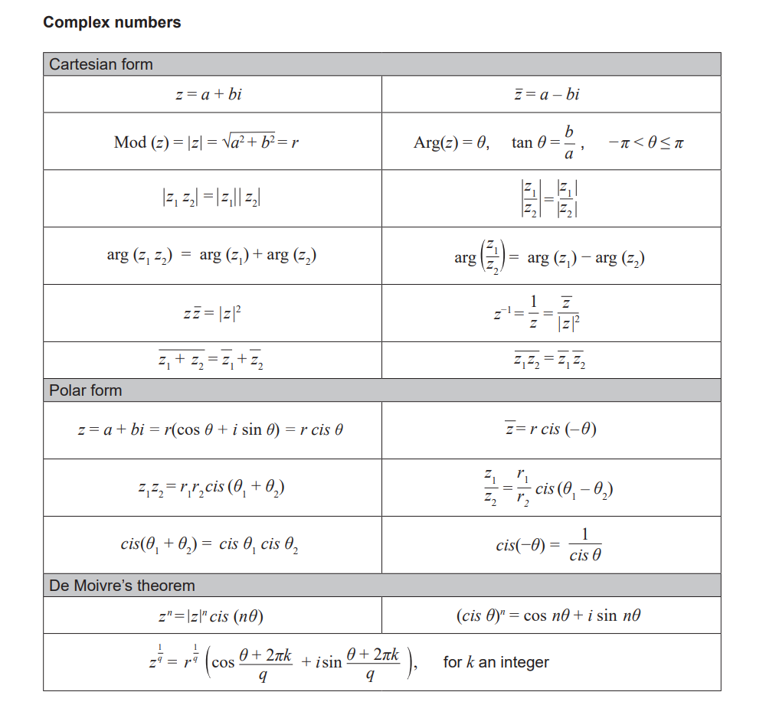





**No cals allowed!!**

Q1 (2, 2, 2 & 2 = 8 marks)

If  and  determine the following:

1. 

|  |
| --- |
| **Solution** |
|  |
| **Specific behaviours** |
| 🗸 real part  🗸 Imaginary part |

1. 

|  |
| --- |
| **Solution** |
|  |
| **Specific behaviours** |
| 🗸 uses conjugate  🗸 express answer |

1. 

|  |
| --- |
| **Solution** |
|  |
| **Specific behaviours** |
| 🗸 numerator  🗸 denominator |

1. 

|  |
| --- |
| **Solution** |
|  |
| **Specific behaviours** |
| 🗸 evaluates square term  🗸 determines answer |

Q2 (2 & 3 = 5 marks)

1. Determine the complex roots of  .

|  |
| --- |
| **Solution** |
|  |
| **Specific behaviours** |
| 🗸 uses quadratic formula  🗸 has two complex roots |

1. Use the quadratic equation to prove that if a quadratic equation with real coefficients has any non-real roots then it must have two complex roots and they must be conjugates of each other.

|  |
| --- |
| **Solution** |
|  |
| **Specific behaviours** |
| 🗸 sets up equation with a negative discriminant  🗸 uses  with discriminant  🗸 derives two complex roots which are conjugates of each other |

Q3 (4 marks)

Determine all possible real number pairs  such that .

|  |
| --- |
| **Solution** |
|  |
| **Specific behaviours** |
| 🗸 sets up equation and equates real and imaginary  🗸 obtains two simultaneous equations  🗸 solves for one pair of values  🗸 solves for two pairs of values |

Q4 (2, 2, 2 & 2 = 8 marks)

Consider the complex number .

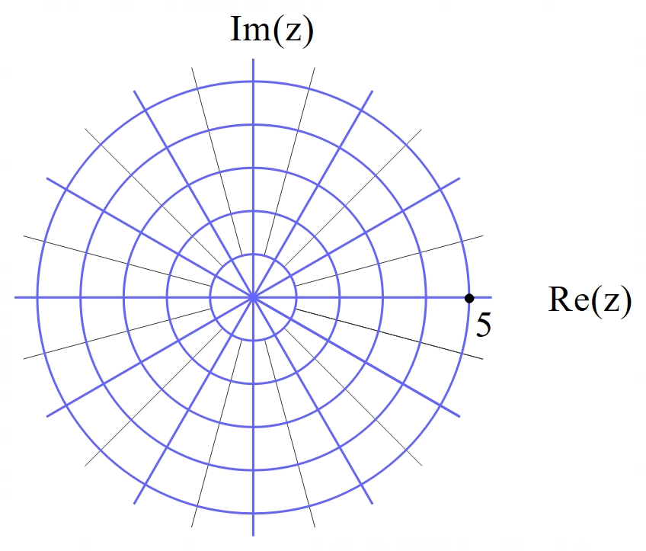

Plot the following on the axes above.

1. 

|  |
| --- |
| **Solution** |
|  |
| **Specific behaviours** |
| 🗸 argument  🗸 length of 2 units |

1. 

|  |
| --- |
| **Solution** |
|  |
| **Specific behaviours** |
| 🗸 uses right angle  🗸 rotates anticlockwise with unchanged length |

1. 

|  |
| --- |
| **Solution** |
|  |
| **Specific behaviours** |
| 🗸 argument  🗸 modulus |

1. 

|  |
| --- |
| **Solution** |
|  |
| **Specific behaviours** |
| 🗸 argument  🗸 modulus |

Q5 (5 marks)

Consider the polynomial  where  are real numbers.

Given that 

and 

Determine the values of .

**(Note: answers without working will receive zero marks)**

|  |
| --- |
| ***Solution*** |
|  |
| ***Specific behaviours*** |
| *🗸 shows reasoning for determining value of a*  *🗸 uses ONE quadratic factor*  *🗸 uses two quadratic factors*  *🗸 shows reasoning in determining quadratic factors (i.e roots in brackets)*  *🗸 shows reasoning on how to determine quartic polynomial.*  *Note: Any statement of values without reasoning will NOT receive any marks!* |

Q6 (2, 1, 2 & 2 = 7 marks)

Consider the locus of complex numbers  that satisfy .

1. Sketch the locus on the axes below.

|  |
| --- |
| **Solution** |
|  |
| **Specific behaviours** |
| 🗸 circle with centre coordinates stated  🗸 goes through origin |

1. State the maximum value of 

|  |
| --- |
| **Solution** |
|  |
| **Specific behaviours** |
| 🗸 states maximum |

1. State the minimum value of 

|  |
| --- |
| **Solution** |
|  |
| **Specific behaviours** |
| 🗸 determines gradient of tangent  🗸 determines min argument |

1. State the maximum value of 

|  |
| --- |
| **Solution** |
| Max =  See above |
| **Specific behaviours** |
| 🗸 determines gradient of tangent  🗸 determines max argument |

Q7 (4 marks)

Consider the roots of the equation  with  being a complex variable with  as a complex constant and  being an integer . A root is defined to be in the first quadrant if the Argument lies in .

Determine **all** the allowable values of such that there will be **exactly** 3 roots in the first quadrant and the smallest argument of these 3 roots will be  .

|  |
| --- |
| **Solution** |
| Note; accept n=15 though point out that SCSA would not! |
| **Specific behaviours** |
| 🗸 uses correct difference in arguments  🗸 sets up inequality for lower n value using 3rd root  🗸 sets up inequality for upper n value using 4th root  🗸 solves for interval of n values  NOTE: any statement that is not supported receives zero marks) |